**Week 4- Homework 3**

**#Part 1 -** Inserting into table ‘hero’ using POST for first time

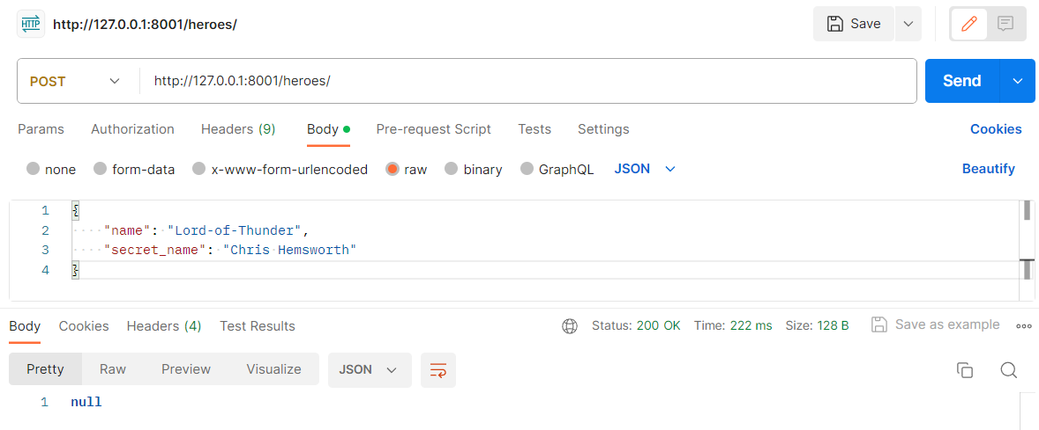

**#Part 2 -** Using GET to get value of a hero ‘Lord-of-Thunder’ from table ‘hero’

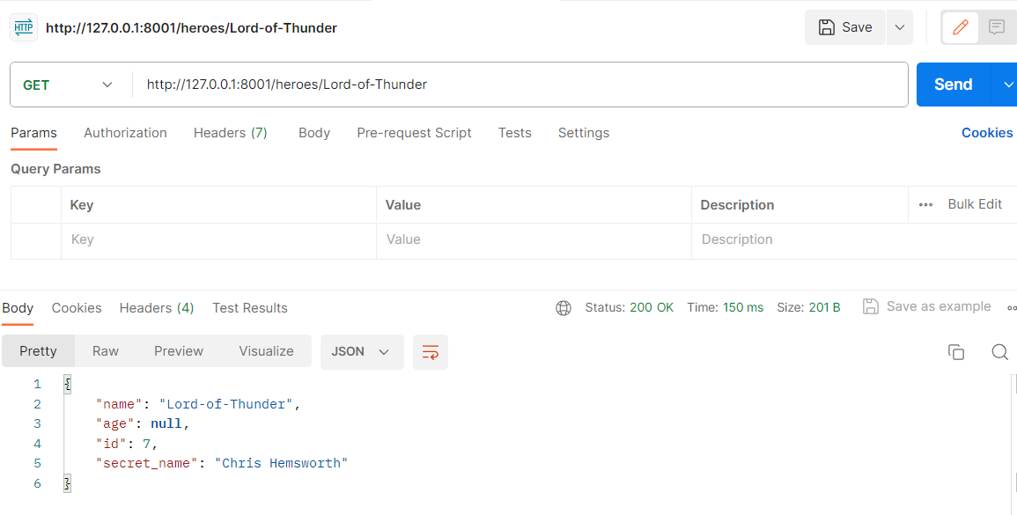

**#Part 3 -** Using GET to get all hero names from table ‘hero’

